Movie Recommendation System
Harshad Lokhande
Ishwar Anand Singh
Aegis School of Data Science

Abstract
Recommendation systems in e-commerce become increasingly important due to the large number of choices consumers face. In general, recommendation systems first take a set of input which could be user profiles, a set of item ratings, etc, identify similarities among the input, and pass the similar pairs for prediction calculation. Among the techniques used in building recommendation systems, collaborative filtering is one of the most promising approaches. LikeMinds, a commercially available recommendation system makes use of collaborative filtering, and our approach is inspired by that system. In this paper, we mainly address the challenges of building an efficient and useful recommendation system given a data set, and discuss our approach on identifying neighbors as well as our prediction heuristics. We also present the results of our experiment where we evaluate the accuracy of our algorithm based on the predictions calculated by trivial algorithms, and the result shows that our algorithm can give accurate ratings.

1. Introduction
The amount of information in Internet is growing so fast that it overwhelms web users. This is also a major problem for e-commerce because online shoppers cannot simply explore and compare every possible product. To alleviate the problem, recommendation systems are introduced to e-commerce. Among all the existing techniques, Collaborative Filtering is one of the most promising approaches to build recommendation systems. Collaborative Filtering collects user's preferences for items, looks for a set of neighbors sharing similar preferences, and infers rating on a particular item based on the information collected from neighbors. With the predicted rating, the system will recommend products which have high predicted ratings to users.
Recommendation system is particularly useful when online merchants are selling large number of products that are in similar domains such as Music CDs, Movies, etc. The recommendation is based on the ratings on products that users have previously rated. A useful recommendation system is efficient since in practice the system handles millions of ratings and prediction is calculated in real times. A useful recommendation system also generates accurate prediction.
We have developed an algorithm of predicting users' movie ratings. In Order to recommend the best movie to users based on their choices and interests. We will make use sample data set to test our algorithm and use the results from trivial algorithms to evaluate our algorithm.

1.1 Challenges
The first challenge is to identify neighbors efficiently. Given a large number of users (6,040 users), a huge items profile (1,000,209 ratings), and a large number of movies (3,900), the system must compute the recommendations within seconds if predictions are to be generated in real time. The process of computing recommendation takes two phases. The first phase is to identify neighbors of the users we are trying to recommend items to. In this phase, the system needs to search through thousands of users and compute the similarities between the candidate neighbors and the targeted user. The second phase is to collect the similarities between the target users and the neighbors and to compute the prediction. Once the prediction is computed, the system will recommend items which achieve a certain threshold of rating to the target user. Given the tasks in these two phases, it is obvious that we need efficient algorithms.
The second challenge is to accurately compute the rating. Before we can compute the prediction, we need information from neighbors. However, how do we identify neighbors in the first place? User ratings are very subjective, so is it possible to extract similarities between users given the ratings of movies? Even if we can somehow identify neighbors, what is the best way to compute the prediction accurately?
In this project, we will have used Collaborative filtering recommender algorithm. We have evaluated the accuracy of our algorithms using the predictions computed by trivial algorithms.

2. Related Work
Collaborative filtering recommender system is a well suited for movie recommender system. Such systems try to predict the ratings of certain items for a target user based on the items previously rated by other users. Using collaborative filtering technique, a recommendation system tries to identify neighbors who have the least rating disagreement to the target users' ratings. The neighbors can be interpreted as having similar taste to the target users', so the recommendation is computed based on information from those neighbors only. LikeMinds is one of the most famous applications using collaborative filtering. LikeMinds essentially try to identify neighbors based on the rating difference of each rating pairs between the target users and the candidates. LikeMinds take a target user and a set of candidate users as input, and computes the closeness based on the rating differences between the target user and the candidate users. The candidate with highest closeness score are considered as a mentor to the target user. The target user's prediction is then computed based on the mentor's rating.

3. Dataset Collection
Data sets have collected from Movie lens website (http://movielens.umn.edu/). There are total 3 files and the data description and details of field are as below:

RATINGS FILE DESCRIPTION (file – rating.dat)
Date description: All ratings are contained in the file "ratings.dat" and are in the following format:

UserID::MovieID::Rating::Timestamp
- File sample as below

1::1193::5::978300760
1::661::3::978302109
1::914::3::978301968
1::3408::4::978300275
1::2355::5::978824291
1::1197::3::978302268
Details:
- UserIDs range between 1 and 6040
- MovieIDs range between 1 and 3952
- Ratings are made on a 5-star scale (whole-star ratings only)
- Timestamp is represented in seconds since the epoch as returned by time(2)
- Each user has at least 20 ratings

USERS FILE DESCRIPTION (file – users.dat)
User information is in the file "users.dat" and is in the following format:
UserID::Gender::Age::Occupation::Zip-code
- File sample as below
1::F::1::10::48067
2::M::56::16::70072
3::M::25::15::55117
4::M::45::7::02460
5::M::25::20::55455
6::F::50::9::55117
7::M::35::1::06810
All demographic information is provided voluntarily by the users and is not checked for accuracy. Only users who have provided some demographic information are included in this data set.

- Gender is denoted by a "M" for male and "F" for female
- Age is chosen from the following ranges:

* 1: "Under 18"
* 18: "18-24"
* 25: "25-34"
* 35: "35-44"
* 45: "45-49"
* 50: "50-55"
* 56: "56+"

- Occupation is chosen from the following choices:

* 0: "other" or not specified
* 1: "academic/educator"
* 2: "artist"
* 3: "clerical/admin"
* 4: "college/grad student"
* 5: "customer service"
* 6: "doctor/health care"
* 7: "executive/managerial"
* 8: "farmer"
* 9: "homemaker"
* 10: "K-12 student"
* 11: "lawyer"
* 12: "programmer"
* 13: "retired"
* 14: "sales/marketing"
* 15: "scientist"
* 16: "self-employed"
* 17: "technician/engineer"
* 18: "tradesman/craftsman"
* 19: "unemployed"
* 20: "writer"

MOVIES FILE DESCRIPTION (file – movies.dat)
Movie information is in the file "movies.dat" and is in the following format:
MovieID::Title::Genres
- File sample as below
1::Toy Story (1995)::Animation|Children's|Comedy
2::Jumanji (1995)::Adventure|Children's|Fantasy
3::Grumpier Old Men (1995)::Comedy|Romance
4::Waiting to Exhale (1995)::Comedy|Drama
5::Father of the Bride Part II (1995)::Comedy
6::Heat (1995)::Action|Crime|Thriller
7::Sabrina (1995)::Comedy|Romance
8::Tom and Huck (1995)::Adventure|Children's
9::Sudden Death (1995)::Action
10::GoldenEye (1995)::Action|Adventure|Thriller
- Titles are identical to titles provided by the IMDB (including year of release)
- Genres are pipe-separated and are selected from the following genres:

* Action
* Adventure
* Animation
* Children's
* Comedy
* Crime
* Documentary
* Drama
* Fantasy
* Film-Noir
* Horror
* Musical
* Mystery
* Romance
* Sci-Fi
* Thriller
* War
* Western

- Some MovieIDs do not correspond to a movie due to accidental duplicate entries and/or test entries
- Movies are mostly entered by hand, so errors and inconsistencies may exist

Raw Data: Sample

"Inside Amy Schumer" (2013) {12 Angry Men Inside Amy Schumer (#3.3)} 2015
"ShitFlix" (2012) {12 Angry Men (#1.19)} 2013
12 Angry Men (1957) 1957
12 Angry Men (1997) (TV) 1997
12 Angry Men and Women (2016) 2016
12 Angry Men: Teams That Don't Quit (1999) 1999
Beyond a Reasonable Doubt: Making '12 Angry Men' (2008) (V) 2008
"5 Second Movies" (2007) {Forrest Gump (#2.3)} 2009
"After Hours" (2010) {Why Forrest Gump Is Secretly Horrifying (#4.12)} 2015
"Border Security: Australia's Front Line" (2004) {Counterfeit Man/Drifter or Grifter/Forrest Gump Part 2/Frog Fat (#2.12)} 2005
"Border Security: Australia's Front Line" (2004) {Forrest Gump Part 1/Oleh Out/Duck Eggs and Buck Choy (#2.11)} 2005
"DVD_TV: Enhanced Version" (2002) {Forrest Gump (#6.3)} 2008
"Feeling Peckish" (2015) {Forrest Gump - Summer Shrimp} ????
"HBO First Look" (1992) {Through the Eyes of Forrest Gump} ????
"Honest Trailers" (2012) {Forrest Gump (#3.19)} 2014
"Merci Qui?" (2008) {Forrest Gump (#1.89)} 2009
"Race to the Scene" (2013) {Race to Forrest Gump & Independence Day (#1.1)} 2013
Forrest Gump (1994) 1994
Getting Past Impossible: Forrest Gump and the Visual Effects Revolution (2009) (V) 2009
Through the Eyes of Forrest Gump (1994) (TV) 1994
"#ByMySide" (2012) {I Feel a Little Sick (#1.4)} 2012
#Seiscientos (2015) 2015
...nur ein Kom�diant (1935) 1935
'Weary Willie' and the Gardener (1901) 1901
*Conditions Apply (2012) 2012
...Po prozvishchu 'Zver' (1990) 1990
"Sh�ten" (1966) {(#1.2115)} 2008
"Six O'Clock News" (1984) {(#1.2115)} ????
# (2012) 2012

Cleaned Data
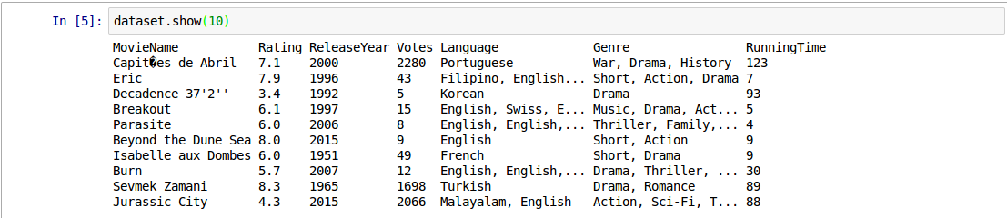

Descriptive Analysis:

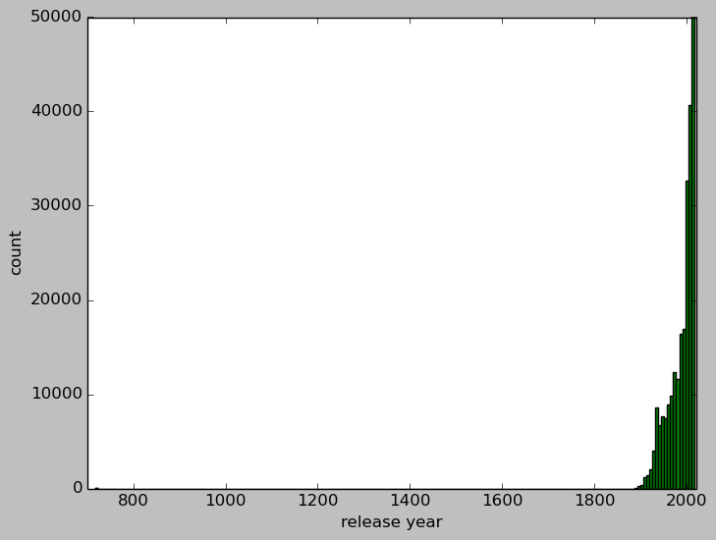
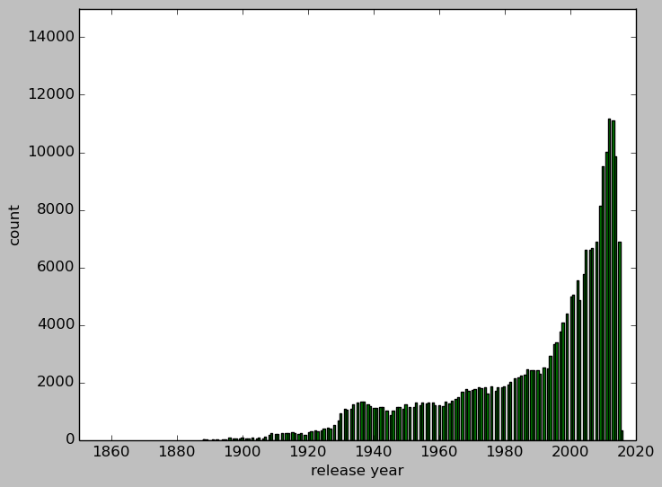

4. Data Ingest
This Recommender system has been developed in PySpark hence all the raw data sets (all three files 1. ratings.dat, 2. movies.dat and 3. users.dat) have loaded for processing further. (Refer code for more detailed steps of Reading the raw files into PySpark).

5. Explore and Preprocess data
The Process steps used for getting data for machine learning algorithm are as below:
- Selection of data [what data is available, missing and can be removed]
This step is concerned with selecting the subset of all available data that we are going to use while working for model development and the below are the selection criteria.
- What is extant of the data available?
- What data is not available which is required to be available?
- What data we don’t require to address the problem?
- Preprocess of data [formatting, cleaning and sampling]
Formatting: The raw data need to format in such a way which is required for processing and fit for the algorithm.
Cleaning: Cleaning of data is the removal or fixing of missing data or outliers.
Sampling: We have large data set available however it require more memory and space hence we need to perform sampling of data from large data sets which can be used for model developing.
- Transform of data
Transformation of data required if the raw data sets are not in the form which is required to develop our model.

6. Create Features
Below are the steps which have been followed while creating features from data sets.
- Feature Selection
It is a manual selection of attributes in our data (such as column in tabular data) that are most relevant to the predictive modeling problem. We have used filter feature selection method which applies statistical measure to assign a scoring to each features. The features are ranked by the score and either selected to be kept and removed from data set.
- Feature Scaling
The preprocess data may contain attributes of mix scaling for different quantity hence we need to make into same scaling and need to insure all the attributes are in same/similar range.
- Feature Decomposition
If there will be features in data sets which represent complex concept that may be more useful to machine leaning method when the data is getting split into constituent parts then we need to perform the feature decomposition.
- Feature Aggregation
We have used this process to aggregate all the features which is required to aggregate into a single feature that would be more meaningful to the problem.

7. Neighbor Identification
We need to identify the closet neighbors to the target user first. Intuitively, to identify the closet neighbor, we need to find the candidates having the least disagreement on movie ratings to the target user. For doing recommendation we have used three datasets files. Which are (1) ratings.dat (2) users.dat & (3) movies.dat.

Suppose if we mix the data sets and try to fit into and readable matrix then data will looks like as below to understand the concept.

Users | Action | Comedy | Drama | Romance | Sci-Fi
Artist | 5 | 3 |  | 4 | ?
Farmer | 4 | 3 |  | 3 | 3
Writer | 4 | 3 | 4 | 4 | 4
Figure Shows writer is a better neighbor to Artist since they generally agree with each other on ratings
Formally, Let U_{a} and U_{b} be the target user and the candidate neighbor respectively. Let R_{a} be the set of movie ratings rated by U_{a}, R_{b} be the set of movie ratings rated by U_{b}, and P_{a,m} be the prediction for the target user on movie M. We summarize the notations we use in this paper in Figure below.

U_{a} | Target user whom we are computing predication for
U_{b} | Candidate neighbor to U_{a}
R(a) | A set of ratings rated by U_{a}
R(b) | A set of ratings rated by U_{b}
pcc(U_{a,} U_{b)} | Pearson Coefficient Correlation of U_{a} and U_{b}
Figure Notations we will use throughout this paper

To evaluate how similar U_{a} and U_{b}, we always compute the disagreement of both users on ratings. In other words, a perfect neighbor’s ratings would completely agree with U_{a}‘s ratings. The first scheme we use is to look for the best neighbor from the set of candidate neighbors. To look for the best neighbor, our system search for candidates who have given the same rating as U_{a} for the movies they both rented, and have the highest number of such occurrence. However, using this scheme would not yield good predictions because we cannot guarantee that the candidates found by using this scheme have the least disagreement to U_{a.} In figure below, assuming U_{a} is Artist while Writer and Farmer is two different U_{b.} In our straightforward scheme, they system would return Farmer as the best neighbor since Farmer completely agree with Artist on two movie ratings while Writer only has one movie rating that is completely agree with Artist. However, it is obvious that the sum of disagreement between Farmer and Artist is three while the sum of disagreement between Calvin and Artist is two. Therefore, our first scheme is not a good one in identifying the best neighbor. In addition, using the ratings from only one neighbor is subject to have inaccurate prediction since we are not taking the user’s subject behavior on movie ratings into account.

Uers | Action | Comedy | Drama | Romance | Sci-Fi | Sum of disagreement to Artist
Artist | 5 | 3 |  | 5 |  | -
Writer | 4 | 2 |  | 5 | 3 | 2
Farmer | 5 | 3 | 4 | 2 | 4 | 3
Figure showing that highest number of agreements on movie ratings is not necessarily imply the least disagreement.

8. Create and select the Model

After defining the problem and preparing the data we need to apply machine learning algorithm to the data in order to solve the below steps and diagram to understand the flow on high level.

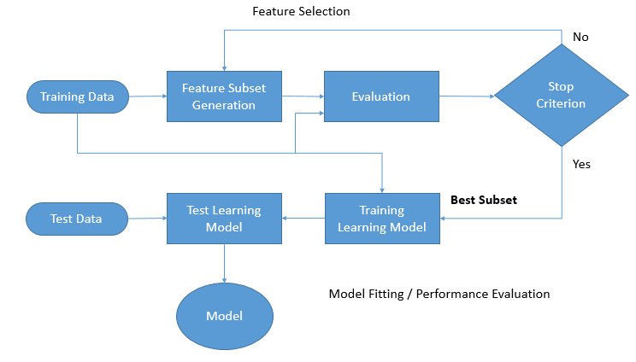
- Segregation of processed data into validation, trained and teat data sets
We have used ASL algorithm (Machine learning algorithm used for collaborative filtering) to trained on training as well as validation data sets to evaluate against test data sets. For this we have selected sample data in to ration of 80:20 for validation_trained data set and test dataset. Further we have segregated the validation_trained data sets into validation and trained data set in 50:50 ratio. (Refer code for more detailed steps and commands)
- Cross validation of data sets
We have used cross validation mechanism which has involved for separating the data sets into a number of equally sized group of instances (called fold). Then model is got trained on all the folds exception one that was left out and prepared model tested on that left out fold. This process is repeated so that each fold get’s an opportunity at being left out and acting as the test datasets. Finally the performance measures are averaged across all folds to estimate the capability of the algorithm on the problem.
- Evaluate the performance
The performance measure is the way we want to evaluate a solution to the problem. It the measurement we have made the predictions made by trained model on the test datasets. (Refer code for more detailed steps and commands)
- Select the Model
We have selected ALS Machine Learning algorithm which is the best for Collaborative Filtering Recommender System and also best for our data sets for which we have developed the Movie Recommender System.
After selecting the best algorithm we have developed the model and evaluated the performance measures and based on the best measure we have finally got the model.

9. Experiments on Movie lens Dataset

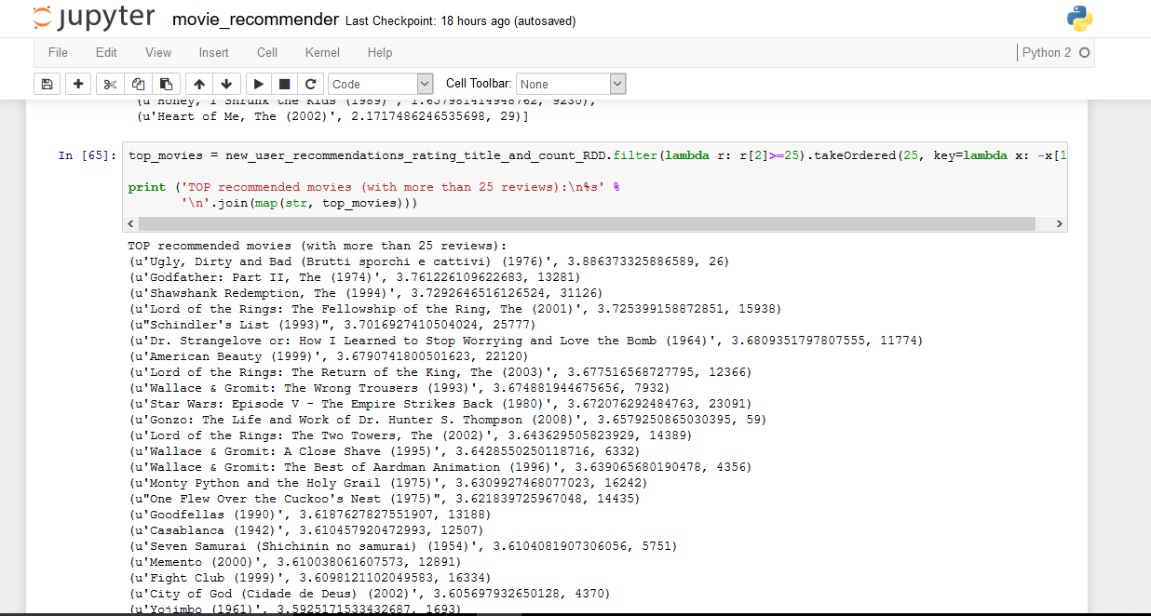

10. Conclusion

In this paper, we present our approach on building a movie recommendation system. We address the challenge of computing accurate rating by first using a straightforward scheme. It turns out that scheme does not work very well since the scheme used the information from only one neighbor to calculate predictions, and the algorithm of determining a neighbor was incorrect. Therefore, we decide to use ALS algorithm. We run the algorithm on randomly generated sets and evaluate the result. The result is better than just using averaging scheme by at least 4%. In the data set, we are able to identify characteristics of the users and the movies, which help us to prune out some of the prediction calculation

The problems of user-based collaborative filtering:

Suppose you have one million users. Every time you want to make a recommendation for someone you need to calculate one million distances (comparing that person to the 999,999 other people). If we are making multiple recommendations per second, the number of calculations get extreme. Unless you throw a lot of iron at the problem the system will get slow. To say this in a more formal way, latency can be a major drawback of neighbor-based recommendation systems.

In user-based collaborative filtering, we are comparing a user with every other user to find the closest matches. There are two main problems with this approach:

1. Scalability. As we have just discussed, the computation increases as the number of users increases. User-based methods work fine for thousands of users, but scalability gets to be a problem when we have a million users.

2. Sparsity: Most recommendation systems have many users and many products but the average user rates a small fraction of the total products. For example, Amazon carries millions of books but the average user rates just a handful of books. Because of this the algorithm may not find any nearest neighbors.

Because of these two issues it might be better to do what is called item-based filtering.

Item-based filtering.

In user-based filtering we had a user, found the most similar person (or users) to that user and used the ratings of that similar person to make recommendations. In item-based filtering, ahead of time we find the most similar items, and combine that with a user's rating of items to generate a recommendation.

Slope One

Another popular algorithm for item-based collaborative filtering is Slope One. A major advantage of Slope One is that it is simple and hence easy to implement.

Part 1 (done ahead of time)

Compute deviations between every pair of items

Part 2

Use deviations to make predictions

Consider our streaming music site with one million users rating 200,000

Artists. If we get a new user who rates 10 artists do we need to run the

Algorithm again to generate the deviations of all 200k x 200k pairs or is there an easier way? You don't need to run the algorithm on the entire dataset again.

That's the beauty of this method. For a given pair of items we only need to keep track of the deviation and the total number of people rating both items.

Slope one recommendation explanation for your reference.

We are using this algorithm for every user Item and user rating in the user's recommendations: For every diffItem that the user didn't rate (item2 ≠ item): add the deviation of diffItem with respect to user Item to the user rating of the user Item. Multiply that by the number of people that rated both user Item and diffItem. Add that to the running sum for diffItem. Also keep a running sum for the number of people that rated diffItem.

Finally, for every different Item that is in our results list, divide the total sum of that item by the total frequency of that item and return the results.

11. Discussion and Future Work

In the future, we expect to address the challenge of efficiency as well. One obvious way to tackle this problem is to parallelize our algorithm.

Another extension is to define a better prediction heuristics. As we have mentioned, our algorithm is very sensitive to the new user and new item problem. One possible extension is to first identify the categories that the target user falls into, and then use a specific heuristic or algorithm which works best for that category and compute the prediction for that user.

Reference
[1] Dataset Source: “Movie lens"
[2] Machine Learning uses "ALS from pyspark"

